Worksheet 1a
Planning your engagement activity - Overview

- What is the issue?
(Outline the service or challenge that you are hoping to improve or change in partnership with children and young people)

- Opportunities or limitations of activity?
(What are the opportunities and limitations of time, staff capacity, resources, or impact that you are working with)

- Which children or young people?
(do you need to speak to specific age ranges? Or children and young people who have experience of specific health conditions or services)

- Recruitment plan?
(where will you find these children & young people? Who do you need to work with to recruit and support them to engage?)

- Barriers to engagement
(what support will these children and young people need to attend / participate? Think about travel, phone credit / Wi-Fi data, privacy (if online activity), nerves or social anxiety, accessibility, personal care support etc)

- What do you (professionals) hope to achieve? (your aims and motivation)

- What do children /young people hope to achieve? (children & young people’s aims and motivation – these may or may not be the same as above – projects should be designed to work for all involved)

- How will you do it? (method - workshop, meeting, individual clinic chats, creative arts etc)

- How will the outcome impact and shape service delivery or change?
(be specific – I will change my practice, I will share with colleagues, I will update our plans, we will change xxx. It is ok also to say what you cannot guarantee from process)

- How will you evaluate, celebrate and share the input of children and young people?
(think about letters and cards of thanks, certificates, vouchers, celebration meals etc and sharing through newsletters, twitter, emails to colleagues etc)

Worksheet 1b
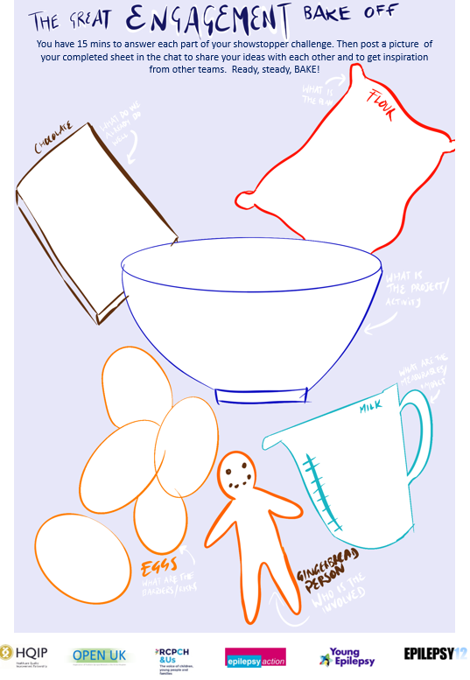
Engagement Showstopper – visual reminder

Worksheet 1c
Engagement Ideas for involving children and young people in service shaping

Ideas from clinicians on the Engagement QI Programme (EnQIP)
- Nerf gun voting
- Smartie voting
- Festivals
- Skittles voting
- Fancy dress outfits
- Through hobbies / sports friendlies / sports day
- Pizza party
- Floor painting / drawing (large brainstorms)
- Art canvas
- Air drying clay
- Murals
- Brainstorming with post its notes for drawing/writing on
- Gaming groups/computer games
- Playdough superhero
- Lego building for areas in clinic

Suggestions from the Children and Young People’s Engagement Team
- Speak to young people in clinic – see clinic chats
- Meet with your hospital youth forum
- Run a workshop at local school, youth centre, PRU, children’s centre
- Attend a local youth forum (council or third sector led)
- Run a photography / art / film competition
- Commission a visual art facilitator
- Work with young peer researchers / outreach team
- Use forum theatre approaches to explore issues
- Host an open day – meet the doctor
- Gather some young volunteers to plan an event to hear from other young people…
- Box stack
- Visual Voting / Menti Voting
- Week of action – ask one question
- Create an activity sheet to do in clinic waiting areas
- Gingerbread people – you / the support around you
- Takeover challenge to review consultation feedback
- Youth social action projects
- Host a roundtable / learning conversation
- Involve them in interviews or board level discussions
- Ask them for their ideas :-D

More activities in the Voice and Choice Action Pack, Recipes for Engagement and Recipes for Rights.
Worksheet 1d
Impact and influence

Before engaging young people there are often other people that need to be engaged – both internal and external stakeholders. This could be for a range of reasons, e.g. to help gain permission or budget for the engagement project, to access networks, to create relationships that can then be accessed for referrals.

It is important to reflect on
- The engagement to action model – where are they on the engagement journey, and what can support them to move towards action?
- What will motivate the person you are trying to engage, as opposed to what motivates you personally.
- What are the main barriers and challenges to the engagement moving forward?

Motivators
- Intrinsic – personal and internal
- Extrinsic – external
- Direct – related to the intended project and outcomes
- Indirect – unconnected to the actual project and outcomes

What Motivates Me | What Motivates them
Key Motivators  Secondary Motivators | Key Motivators  Secondary Motivators

Barriers and challenges
- Capacity, skills, knowledge
- Beliefs
- Strategy, process, delivery
- Practical barriers for participants
- Organisational barriers, systems and structures
- Relational barriers

Barriers & challenges (my view) | Barriers & challenges (their view)

Worksheet 1e
Planning your engagement activity – Logistics

Getting the children and young people there
Activity | Progress/Lead
Create activity publicity (poster etc) graphic design and draft text
Publicise through Social media – twitter, Facebook groups etc
Identifying, contacting and building relationships with partner organisations
Contacting, engaging, building relationships and selling opportunity to children and young people
Communication and liaison with parents / carers
Design and prep activity
Activity | Progress/Lead
Activity design (for different age and stage)
Preparing and gathering resources for workshops
Agreeing who facilitates session
Hiring specialist facilitators
Booking rooms or setting up online links
Risk assessing activities
Agreeing first aid / safeguarding leads
Pre and post activity communication with children, young people, parents and partners
Accessibility logistics
Activity | Progress/Lead
Travel ‘agent’ for in person meetings
Data / IT access for online meetings
Personal care support
Translation /interpretation and communication needs
Accessibility check of activities

Remember to check
Safeguarding links and template documents for work with CYP
Digital work links including safeguarding

Worksheet 1f
Example group work session plan

Overall aim of workshop / session: Duration:
Number of participants: Date:

Time / duration | Activity / topic | Resources needed | Who leads
 | Welcome
 | Having a good virtual meeting (Aka - group agreement)
 | Intros and check in
 | Aim of session
 | Icebreaker
 | Activity 1
 | Activity 2
 | Sum up and next steps
 | Check out, signposting
 | Thanks, and close

Worksheet 1g
Example group agreement and end of session signposting

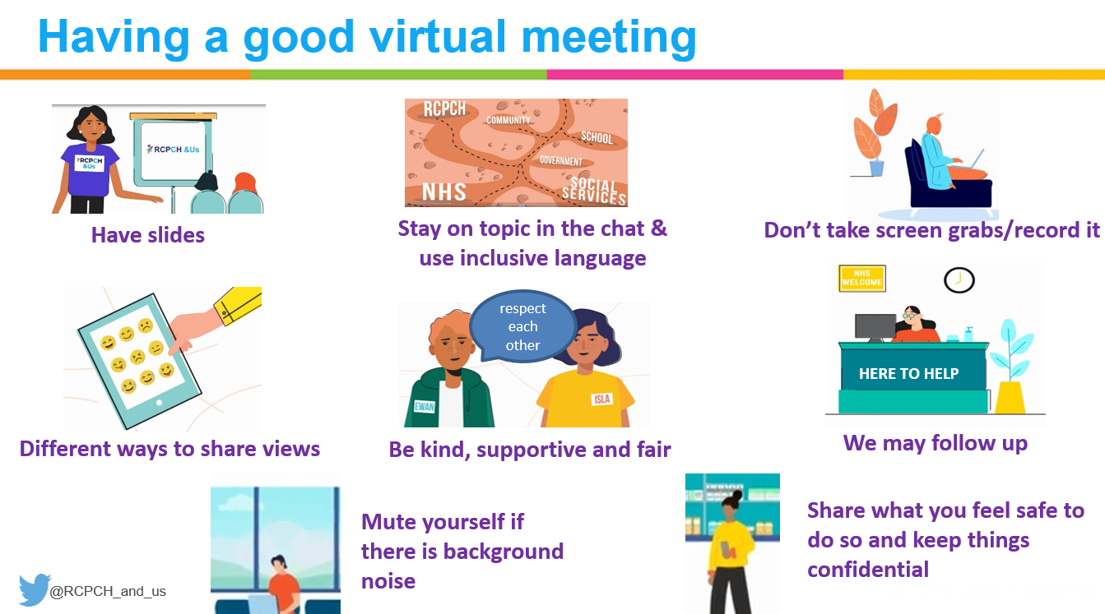

You might have worries or concerns that won’t get answered in the session, or new things that you hear that you want to talk about. You can get in touch with some of the national support services, not just about the session topics, but about other things that might be going on in your life:

The Mix, a charity supporting young people/young adults online or by phoning 0808 808 4994.
Childline for support for children and young people online or by phoning 0800 1111
BOLOH helpline for Black, Asian and minority ethnic groups of young people
Papyrus Hopeline for those experiencing thoughts of suicide
Kooth App for supporting young people’s mental health
NHS Every Mind Matters lots of different resources for all ages
Give us a Shout online or text SHOUT to 85258 for all age support
Student Space with support for students during the Coronavirus pandemic
Young Minds with detailed support for young people, parents and professionals
Wellbeing support for workers
Blue Light Programme which supports emergency workers

